Weekly report

1. **My *Goals* from last week**
   1. Make new pictures for IJRR paper with green robots, cyan arrows, a black object, and no grey circle
   2. Make the Orientation Control Experiment work for the remaining 25 percent of the time
      1. Make the correct portion flow around despite what angle the code is at
      2. Make the robots go into variance control when object is at the correct angle
   3. Get good data for covariance experiment
   4. Learn how to spell “experiment” as I keep spelling it wrong in these weekly reports for some reason…
2. **My *Accomplishments* this week**
   1. Project 1: <Orientation Control Experiment>
      1. Fixed the problem where the potential field was on the wrong side
         1. Below is the old picture vs the new picture

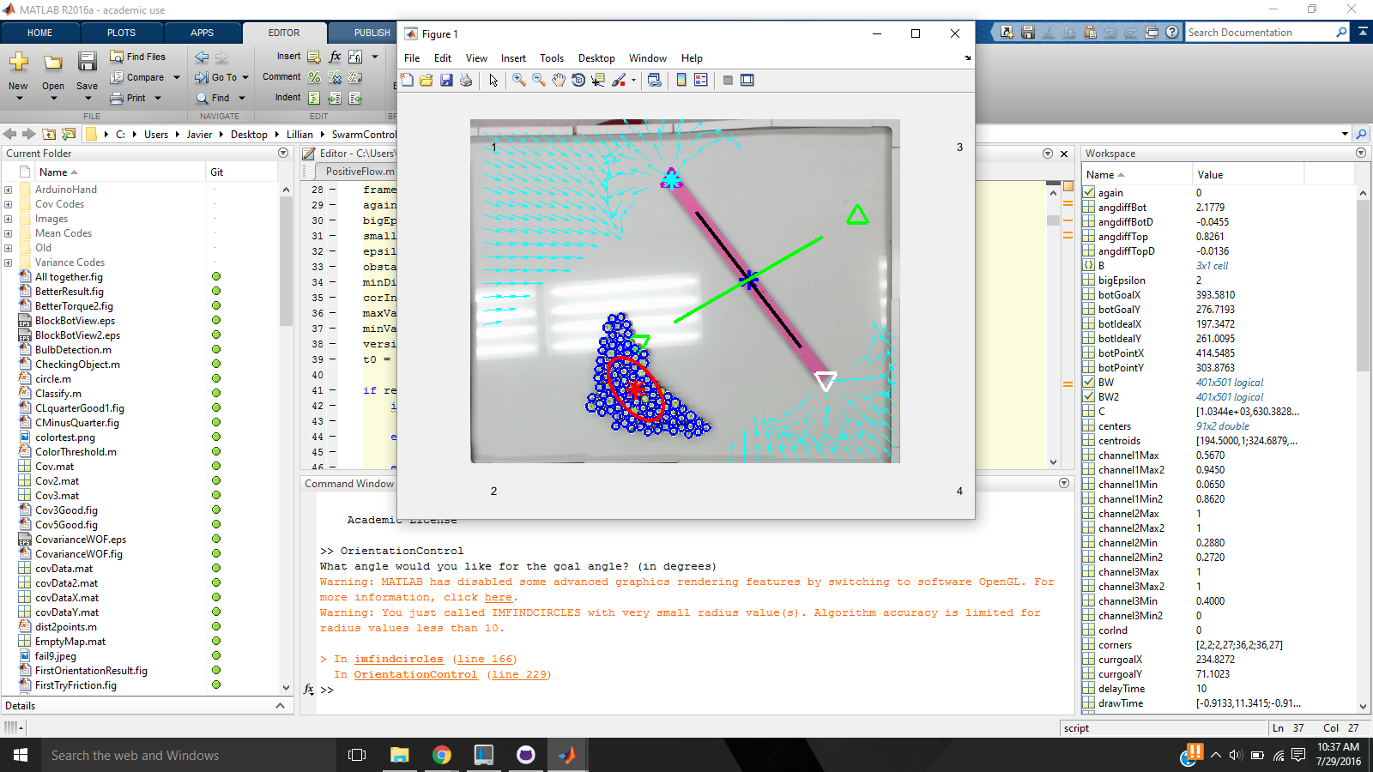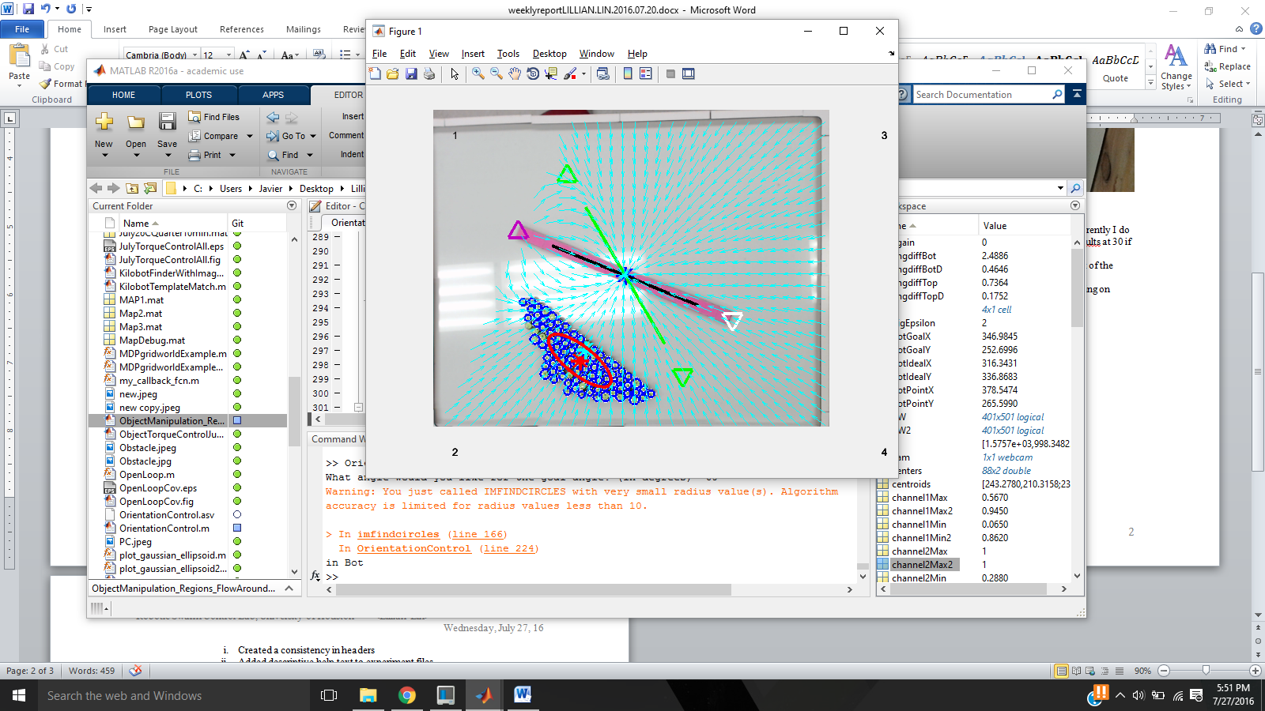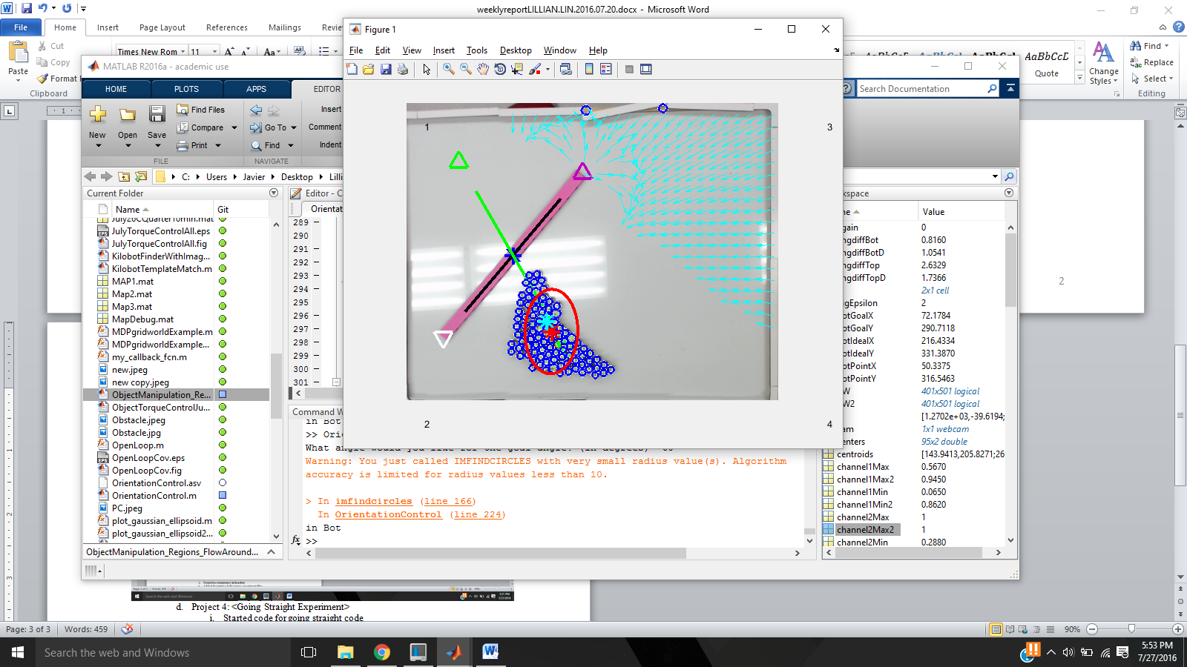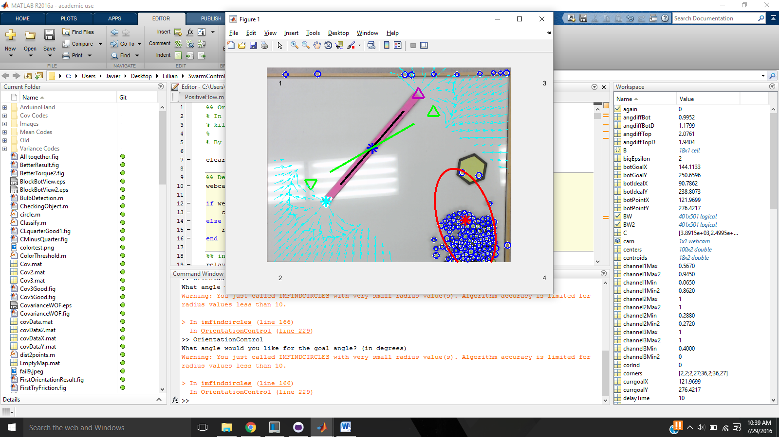

Figure 1 - Top is old code with problems and bottom is the new code with fixes

* + 1. Created a function to always make angles between 90 and -90 or 180 or -180 depending on what the user wants
    2. Shiva Changed the code to interpret 90 as 0 and then the angle from that and I debugged an issue it had in which the code was not saving or plotting correctly
       1. *<Deliverable 1> This code is on a new branch Intermediate Goals under the same name OrientationControl.m*
    3. Created another intermediate goal so that when the goal switches from the positive angle to the negative angle it would not make the robots try to move directly there but at a new goal tangent to the object
  1. Project 2: <IJRR Paper>
     1. Created pictures for flow around
        1. Experiment Pictures

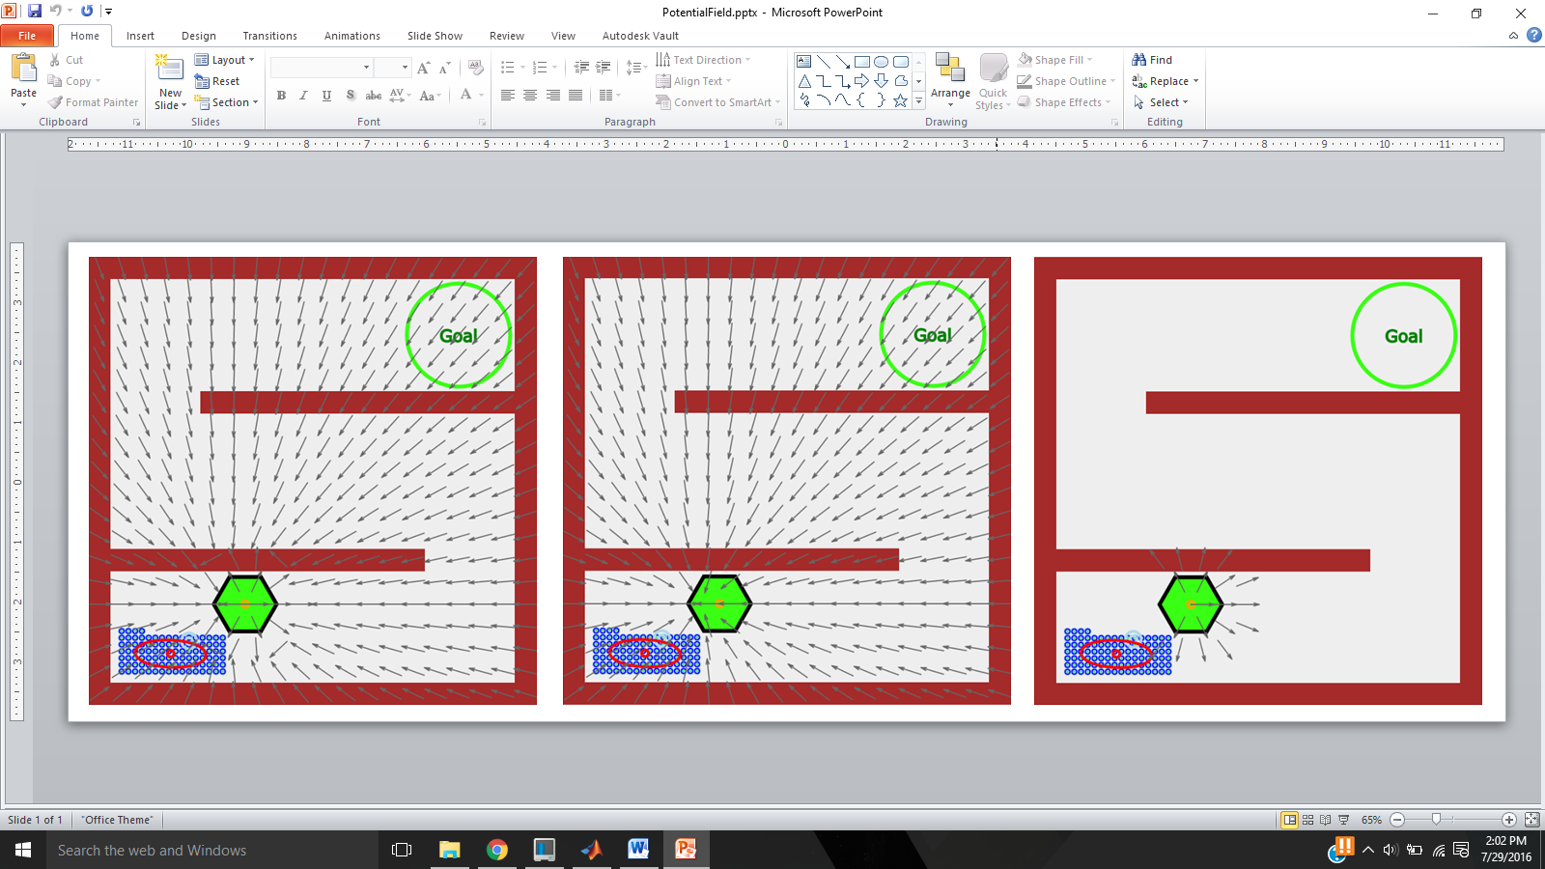

Figure 2 - (left:) Complete Potential Field (middle:) Attractive Potential Field (right:) Repulsive Potential Field

* + - 1. Simulation Pictures
      2. *<Deliverables 2, 3, 4 & 5> All pictures seen above can be found as well as the simulation pictures in SwarmControlSandbox/papers/journalSwarmControl/picture/pdf/ 🡪 PotentialField.pptx, negativePotential.eps, PositivePotential.eps, and PotentialFieldView.eps (I don’t know how to open an eps file so I could not add to the report.*
    1. Made snapshots with time

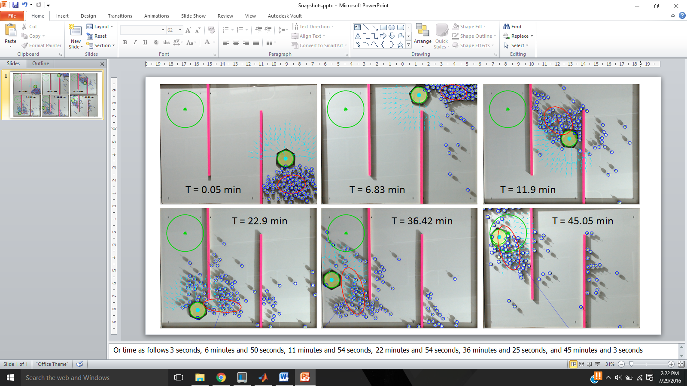

Figure 3 - Pictures with time stamps

* + - 1. *<Deliverable 6> Can be found as well as the simulation pictures in SetUp.pptx*
    1. Created set up picture
       1. Took new table picture + edit
       2. Added vector art of webcam and lights
       3. Added new labels

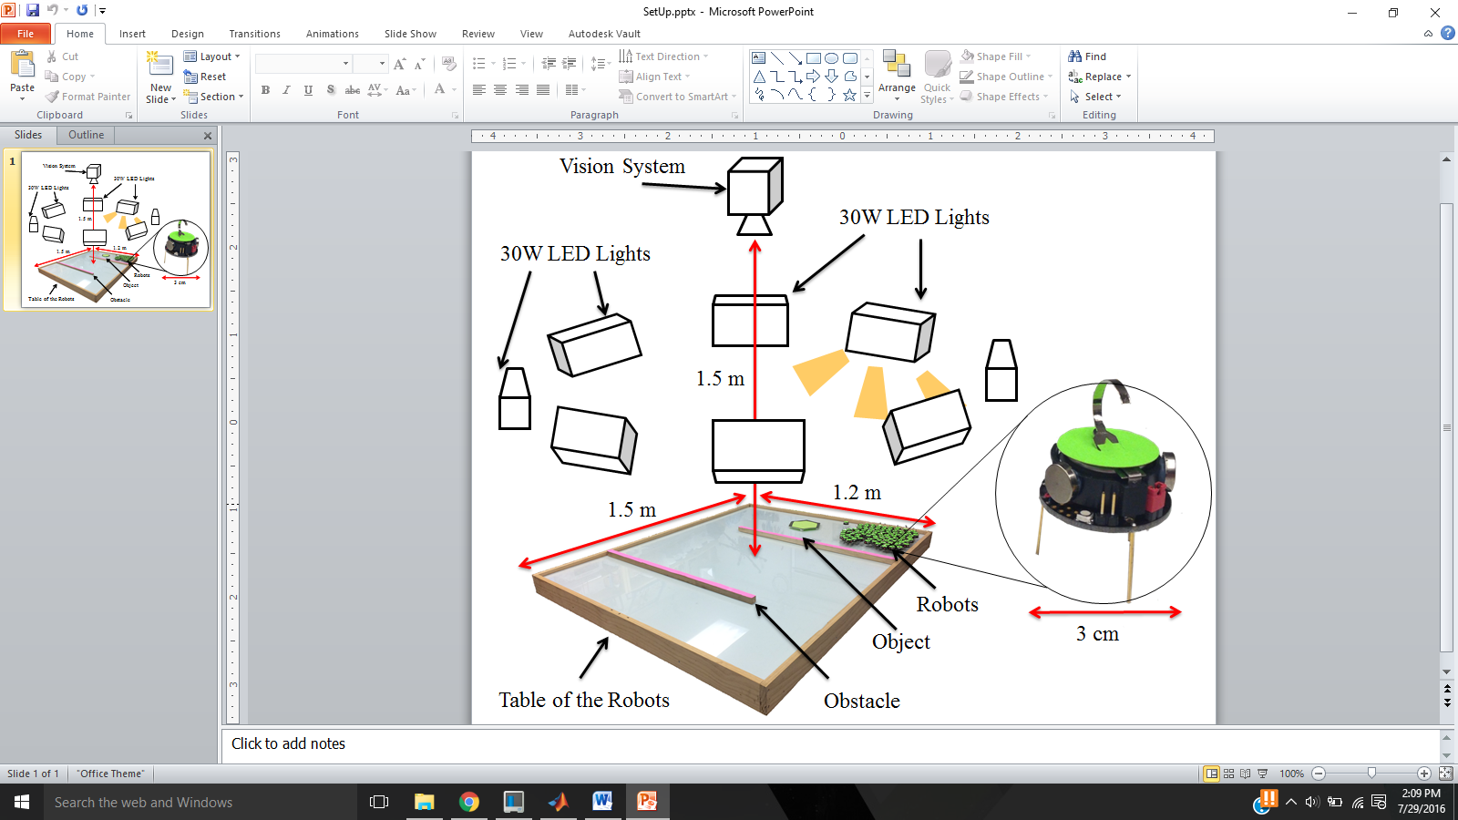

Figure 4 - Setup Picture

* + - 1. *<Deliverable 7> Picture above can be found in SwarmControlSandbox/papers/journalSwarmControl/picture/pdf/SetUp.pptx*
  1. Project 3: <Covariance Experiment>
     1. Created new pictures using Shiva’s phone
  2. Project 4: <Going Straight Experiment>
     1. Made the code always make the angle 90
     2. Make the goal back up once it orients the object
     3. Makes the goal the center of the object when the object is 90 degrees
  3. Project 5: <Other>
     1. Fixed table so that it is white in the web camera pictures
        1. Removed the table edges
        2. First coat paint
        3. First Sand
        4. Second coat of paint
        5. Second sand
        6. Re-screwed the table edges

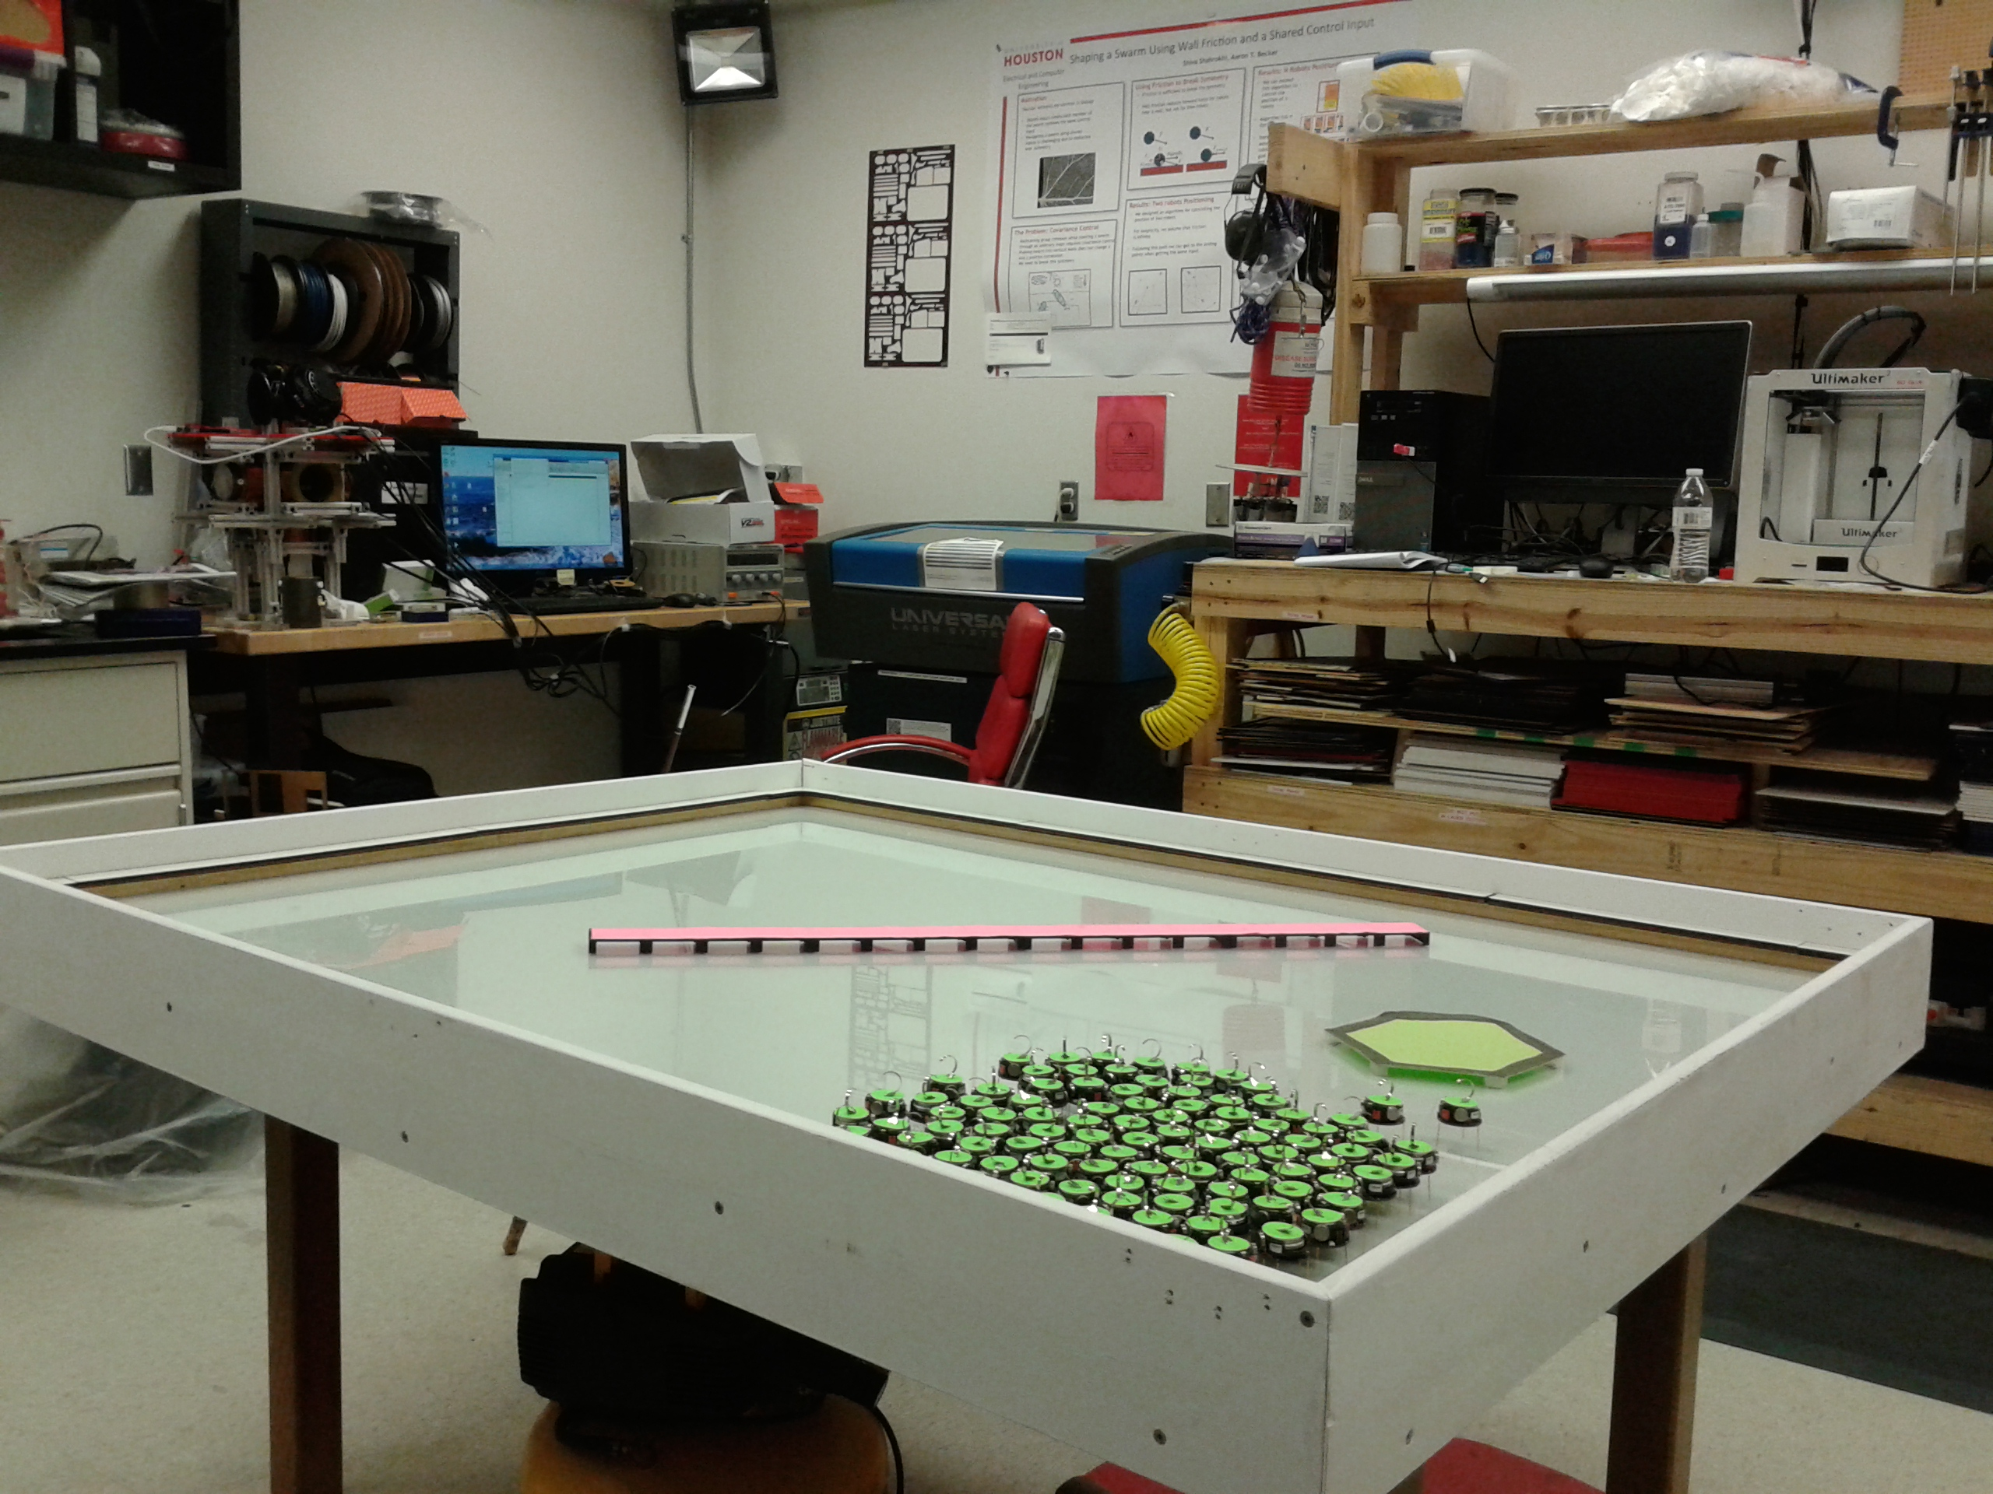

Figure - Table with new white border

* + 1. Moved out of my apartment
    2. Got a response from United Airlines about a co-op
       1. Talked to Dr. Long about SURF status if I take co-op
       2. Started conversation about status of the William A Brookshire scholarship

1. **My *Goals* for next week**
   1. Create the labels for the Covariance experiment Dr Becker asked for
      1. Need to borrow Shiva’s computer for the pictures of table
      2. Take measurements of robot or find datasheet to find these values
   2. Get data for new code of Orientation Control experiment
   3. Make SURF poster
   4. Get someone to take over my lease or convince the apartment complex to not make me pay 100% of my remaining rent
   5. Give United a response
   6. Completely figure out what I need to do about my fall/Classes/ect
      1. Continue to talk to Dr Long
      2. Make appointment with Yolanda
      3. Figure out about REU